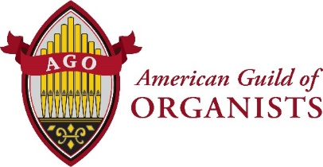

Date
Dear Reverend (Name)
We encourage you to think about the important part your church musicians play in leading successful worship. The psalms and other documents of the early church tell us of the strong heritage of music in worship, and it would be difficult for us to imagine a service that does not express our faith through this.
The American Guild of Organists whose vocation is music ministry in churches, synagogues and educational institutions, serves 12,000 members with over 270 chapters throughout the United States and abroad. The AGO provides certification programs, online learning and a multitude of resources to support the needs of people who select music, rehearse choirs, and play hymns and service music to proclaim and interpret scripture in worship. One of the most cost effective benefits for your church is the 10% discount at SheetMusicPlus, www.sheetmusicplus.com, offered only to AGO members. SheetMusicPlus offers over 18,000 preludes, postludes, hymns and choir arrangements for each liturgical season. We also offer a 5% discount to AGO members at OneLicense, https://www.onelicense.net. These savings can easily cover the cost of membership in the AGO for your church musician.
Learn more about the American Guild of Organists and information about our local chapter at https://www.agohq.org/membership/membership-overview/. We hope that you will encourage and support your church musicians to become members of the AGO.
Warm regards,
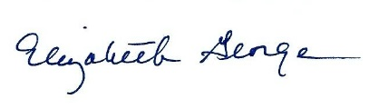
Chief Membership Officer
American Guild of Organists
475 Riverside Drive, Suite 1260
New York, NY 10115
elizabeth.george@agohq.org
www.agohq.org

