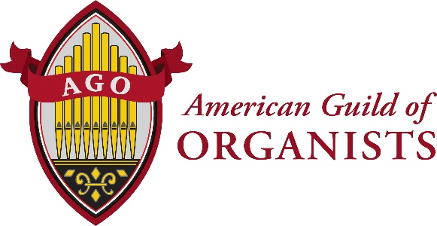

Dear (Name)
This letter is to encourage you to think about the important part your church musicians play in leading successful worship. The Psalms and other documents of the early church tell us of the strong heritage of music in worship and it would be difficult for us to imagine a service that does not express our faith through this.
Many personal and professional skills are necessary to accomplish this important part of worship. These skills are continually supported by the American Guild of Organists, the national professional association serving the organ and choral music fields. The AGO serves approximately 12,000 members with over 270 chapters throughout the United States and abroad, whose vocation is music ministry in churches, synagogues and educational institutions. The AGO provides certification programs, online learning and a multitude of resources to support the needs of people who select music, rehearse choirs, and play hymns and service music to proclaim and interpret scripture through their musical selections and performance.
We hope that you will encourage and support your church musicians to become members of the AGO. Your congregation will benefit from the enhanced professional skills that we provide.
You can learn more about the American Guild of Organists at https://www.agohq.org/membership/membership-overview/ and find information about our local chapter at ________. A digital sample copy of THE AMERICAN ORGANIST is available upon request.
We look forward to welcoming your musicians to the AGO!
Warm regards,
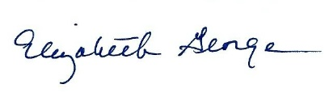
Chief Membership Officer
American Guild of Organists
475 Riverside Drive, Suite 1260
New York, NY 10115
elizabeth.george@agohq.org
www.agohq.org

