SOCIAL MEDIA: TIPS AND TRICKS FOR YOUR CHAPTER
By Leslie C. Smith, CAGO
Social media is a powerful tool which, when well utilized, can create buzz about your chapter, publicize events, and allow potential members to learn about the best of your chapter: the people, the educational events, and the potential for musical inspiration and growth.For the purpose of this article, we are examining three of the main social media services: Facebook, Twitter and Instagram. This article approaches social media from the perspective of new users, hopefully empowering multiple people within each chapter to utilize social media for their chapter’s benefit.
All Facebook users create a profile page, which includes pictures, information, hobbies, etc., using their real name. From there, users can find friends, acquaintances and colleagues and send a “friend request”. This, after the other party confirms, creates a link between the two profiles. When a “friend” writes a status update, posts a picture, or shares a link, it will appear on the newsfeed. The news feed is a rolling, continually updating homepage that is specific to each user.
Pages:
There are many overlaps in the services offered by Facebook and a website. You can plan events, communicate with members, and share pictures and video from past events, to name a few. The benefit of maintaining a social media presence in conjunction with a website is that others can be drawn to your chapter through their friends and colleagues. The actions (attending a concert, commenting on a photo, etc) are seen in the newsfeeds of potential members, thus piquing interest and creating traffic to your website, and hopefully, the chapter. It is recommended that every chapter have a Facebook Page and include a link to the HQ national page.
Pages offer five different administrator roles: manager, content creator, moderator, advertiser and insights analyst. The number of administrators (admins) you can have is unlimited. It is recommended, however, that admins are kept to a minimum and that there is a great deal of communication between admins to avoid conflicts and repeat postings.
Events:
Facebook is an easy and powerful way to promote chapter events. Members that have “liked” your page (more on that below) will be automatically notified of the event. Also, your members can then “share” the event to their friends, spreading the word about your event and inviting others.
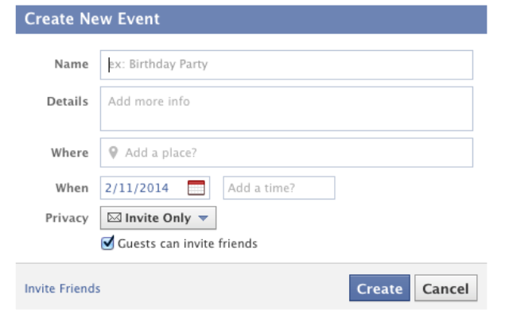
Because many Facebook users are interacting with the service via a mobile device (and thus with limited screen size) you should keep your event name short. Example: “Recitalist’s name in Concert” versus “American Guild of Organist’s Chapter Event: Recitalist’s name in Concert”. The details section is a great place to share with members those details. Also, when users are notified of the event, it will read as: “Your Chapter’s Page Name has invited you to Name of Concert,” which means that the name of the chapter will automatically be included in the invitation. Note: the invite notification will also include the page’s profile picture, so make sure you have one!
The “like” button gets more than 1 billion clicks per day. The power of the “like” cannot be understated. The “like” button is 21st century word-of -mouth. The more people “like an event, picture, or video, the more people will be drawn to your page and therefore your chapter. A picture is worth a thousand words. As mentioned above: always shave a profile picture. Even better, when first starting a page, upload a number of images from previous chapter events. Every picture will give potential members a better sense of what it means to be a part of the AGO. As well, a video is worth a thousand pictures. They needn't (and often shouldn’t) be long or involved, but a short clip can give great feeling and personal touches to your page and profile. Consider a quick “Hello from POE 2015!” or short promotional video inviting members to a concert, event, or lecture. The possibilities are truly endless.
What posts promote interaction? Consider what you interact with regularly: fun pictures, humorous status updates and interesting articles. There is no “one size fits all” approach to interacting with your members. Share the stories and people of the chapter. Show how your chapter is a place for education, camaraderie and professional support.

Twitter (twitter.com) is a microblogging service. All posts on Twitter (“tweets”), which are similar to the original Facebook status posts, are limited to 140 characters. Like the news feed on Facebook, people and companies you follow will appear on your feed when they send a tweet. These tweets can then be “favorited” (the Twitter equivalent of the Facebook “like”) or sent on to friends. The hashtag (#) is a popular way to add a topic or clever caption to a picture or tweet. Other Twitter users can, upon reading your tweet, click on the hashtags and see other posts that have the same hashtag. Also, users can find your tweet by searching, for example, “POE” and see all the tweets that have the same hashtag.
Instagram: (instagram.com) was originally conceived as a photo-sharing service which now includes video. It is easiest used from mobile devices as an “app.” Instagram is a way to share great looking candid and posed pictures with short commentary. Images on Instagram are notably square. Your chapter will, like the other services, need to create a username and password. The app encourages the use of photo filters, which create a desired mood or coloring. With the flexibility of Instagram and its functions, you can share great behind-the-scenes images with members and friends.
Social media étiquette: Social media etiquette is very similar to normal business etiquette. Remember that what you post and what you type is attached to the name and the image of the AGO. As with anything you would put on the Internet, share with care. The Internet never forgets!
Social media integration: Maintaining a presence in these various services individually can be exhausting. Let them do the work for you!
- When you create a Facebook event, share it on Twitter.
- Tweets can be shared on Facebook. Go to Settings (the “gear” icon), then Profile. There, you will see an option to Connect to Facebook. Follow the on screen directions to have all tweets (under the chapter’s twitter account) sent to the Chapter Facebook page.
- When publishing an image on Instagram, you can opt to share it also on Twitter and Facebook. You will find this option after the filters but before you hit “share”. The selected services will turn from black to blue:
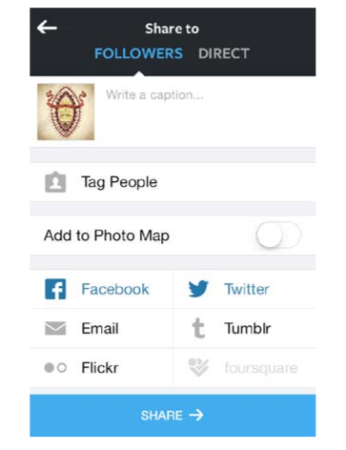
There is no “one size fits all” approach to social media. The best solutions for you and your chapter are ones that are sustainable and reasonable for the size of the chapter and the resources available. Consistent postings and interactions are key to a successful social media presence. Social media can be a very effective tool for communicating with members and potential members.

