Monday, January 25th, 7:30-9:00 pm ET: Collaborate!

- 7:25: For those of you who did not get to see the recording of opening remarks from Reverend Fentress-Williams, please join us at 7:25, as we will be replaying it.
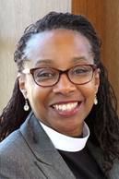
Opening Remarks: Reverend Judy Fentress-Williams, AGO’s New Chaplain

- 7:30 pm General Session: Welcome by Elizabeth George, Director of Member Engagement and Chapter Development and review of results from the pre-conference survey. Goals for tonight’s meeting.
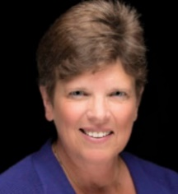
Opening Remarks: Dr. Vicki Schaeffer, DMus
Councillor for Membership

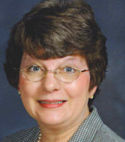
Leadership Talk #1: Dealing with Leadership Challenges
Caron Farmer, MA, AB, AAGO, Great Lakes Regional Councillor

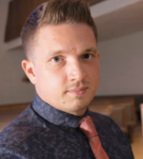
Leadership Talk #2: Collaboration
Skye Hart, DMA, West Regional Councillor

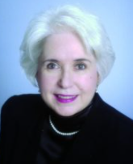
Leadership Talk #3: Leadership Accountability
Sue Mitchell-Wallace, MM, FAGO, Southeast Regional Councillor

- Zoom Room Breakout Sessions for: Dean, Sub-Dean/Programming, Membership, Communications, Finance

- 8:45-9:00 General Session: Elizabeth George Q&A with chapter leaders. What did you learn today that you can apply in your leadership roles?

Tuesday, January 26th, 7:30-9:00 pm ET: Create!

- 7:30 pm General Session: Welcome by Michael Bedford, AAGO, ChM, DMA
President of the National Council
- Goals of for tonight: Elizabeth George, CMM, Director of Member Engagement and Chapter Development
Leadership Talk: Technology
Leslie Smith, CAGO, MM. Northeast Regional Councillor and Convener of Regional Councillors

The Dysfunctional Nominations and Elections Process
The Board Meeting of the Copacabana Chapter

Dean: Stephen Price
Sub-Dean: Vicki Schaeffer
Secretary: Leslie Wolf Robb
Treasurer: Leslie Smith
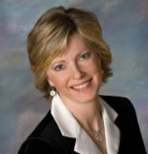

Leadership Talk: The Importance of Setting Goals
Karen Black, DM North Central Regional Councillor

- Elizabeth George explains how to create SMART goals and utilize the template in the handouts.

- 8:00-8:30 General Session: Zoom Room Breakout Sessions by Chapter Size:
Creating Three Goals for the Next Five Months

- 8:30-9:00: Chapter leaders will share the goals they’ve created. How will these goals help the chapter to keep moving forward to continuously engage its members?

- Closing Comments by James Thomashower

