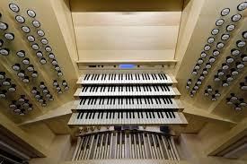

### **The mission of the American Guild of Organists is to foster a thriving community of musicians who share their knowledge and inspire passion for the organ.**

### **The vision of the American Guild of Organists is to engage, support, and uplift every organist**.

### **AGO Chapter membership has many benefits**

### 

Our chapter members include professional and amateur organists, choral directors, other musicians and clergy involved in church music, as well as those who simply enjoy choral and organ music.

**Fellowship:** Each month there is a wonderful opportunity to interact with people who have concerns and interests similar to yours.

**Programs:** Our chapter is known for its excellent programs and workshops; all designed to increase members’ knowledge and skills. As you can see from the enclosed calendar, we have a wide range of programs, recitals and worship opportunities scheduled for each month from July through June.

**Job Postings**: jobs posted on our website and on www.agohq.org,

**Publications:** our monthly newsletter and **The American Organist** magazine.

**Certification Programs** and online education at www.agohq.org.



For additional information please

contact us at:

**Welcome to the**

**(insert name)**

**Chapter**



Your Logo Here

**As a member of the American Guild of Organists you can**

Þ **Connect with other organists**

Þ **Enhance your skills as an organist and choral director**

Þ **Share knowledge and expertise**

Þ **Access job listings**

Þ **Enjoy meeting new friends at chapter events**