Dimensions of Praise: The Organ in Worship
La Mesa First United Methodist Church
July 19, 2017, 2:00 p.m.
Prelude
Welcome
Please stand as able.
Opening Sentences (Psalm 96: 1-2, 11, 9)
Leader O sing to the Lord a new song; sing to the Lord, all the earth.
People Sing to the Lord, bless his name; tell of his salvation from day to day.
Leader Let the heavens be glad, and let the earth rejoice;
People Let the sea roar and all that fills it.
Leader Worship the Lord in the beauty of holiness.
People O come, let us adore him.

- Praise
UMH #64 Holy, Holy, Holy (verses 1 and 4) Nicaea

Please be seated.
A reading from the Letter of Paul to the Colossians 3: 12-16
As God’s people, holy and beloved, clothe yourselves with compassion, kindness, humility, meekness, and patience. Bear with one another and, if anyone has a complaint against another, forgive each other; just as God has forgiven you, so you also must forgive. Above all, clothe yourselves with love, which binds everything together in perfect harmony. And let the peace of God rule in your hearts, to which indeed you were called in the one body. And be thankful. Let the word of God dwell in you richly; teach and admonish one another in all wisdom; and with gratitude in your hearts sing psalms, hymns, and spiritual songs to God.

Reader: The word of the Lord.
People: Thanks be to God.

- Adoration
Psalm 145 (Refrain sung first by cantor, then by all)

Music and antiphon text © 2005, The Collegeville Composers Group. All rights reserved.
Published and administered by The Liturgical Press, Collegeville, MN 56321.
- Confession
Kyrie eleison with improvisation Gregorian chant, Missa cum iubilo

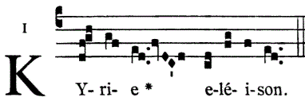

Lord, have mercy.

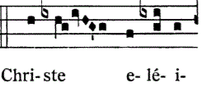

Christ, have mercy.

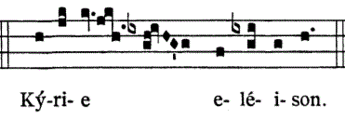
Lord, have mercy.

Please stand as able.
- Forgiveness
UMH #378 Amazing Grace (verses 1, 3, 6) New Britain

Please be seated.
Reflection

Meditation

- Supplication Taize
(sung following each petition)
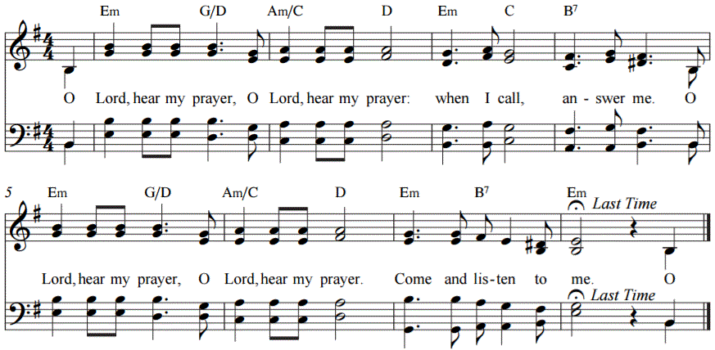
- Thanksgiving
Psalm 150 (read alternating at the verse by side, beginning on the right)
1 Hallelujah! Praise God in his holy temple;
praise him in the firmament of his power!
2 Praise him for his mighty acts;
praise him for his excellent greatness!
3 Praise him with trumpet sound;
praise him with lute and harp!
4 Praise him with tambourine and dance;
praise him with strings and pipe!
5 Praise him with clanging cymbals;
praise him with loud-clashing cymbals!
6 Let everything that has breath praise the Lord!
Hallelujah!
Please stand as able.

UMH #62 All creatures of our God and King (verses 1, 3, 7) Lasst uns erfreuen

Dismissal
Leader Go in peace, rejoicing in the power of the Spirit.
People Thanks be to God.

Postlude

Christopher Cook and Nathan Costa, worship leaders and presenters
Meaghan King, Stephen Price, Nicole Marane, Josiah Armes, organists

